

**Qagent & Report generation USer MAnual FOR ORACLE FUSION CLOUD**

**INDEX**

|  |  |  |
| --- | --- | --- |
| ***S.NO.*** | ***CONTENTS*** | ***PAGE N0.*** |
| 1 | Introduction | 2 |
| 2 | Downloading Qgent and uploading data | 2 |
| 3 | Adding remote SFTP server in OBI | 6 |
| 4 | Firewall access for Qagent | 9 |
| 5 | Generating the ALLROLES.CSV file | 10 |
| 6 | Generating the ALLUSERROLES.CSV file | 11 |
| 7 | Appendix | 23 |

# **1. I****ntroduction**

This document will help QCloud tenants to setup and configure QAgent to run an audit for Oracle Fusion Cloud.

**2.** **Downloading QAgent & Uploading Data**

Once the sales user of QSoftware approves the audit, the customer (whose email was specified in the Audit Request Form) will receive an email notification as below.

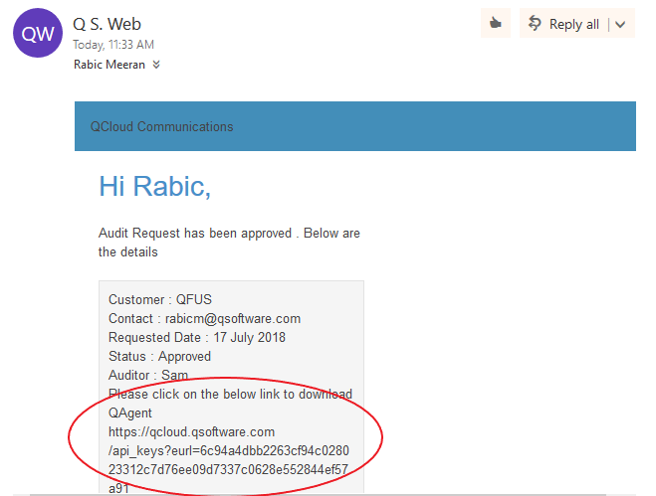

Step 1: Click on the highlighted link in the mail to download the QAgent

Step 2: You will be able to view the button ‘Download QAgent’ as shown below. Click on the button to download the QAgent.

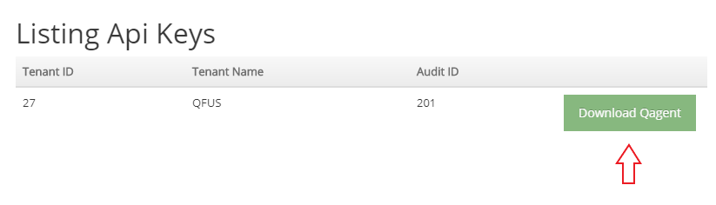

Step 3: Once the QAgent is downloaded, unzip the QAgent.zip file

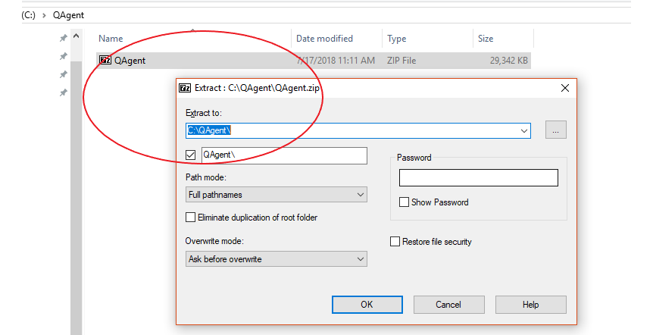

Step 4: After extracting the Qagent.zip, double click on execute.cmd

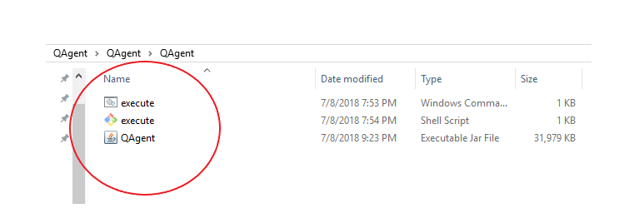

Step 5 : The Qagent UI will open.

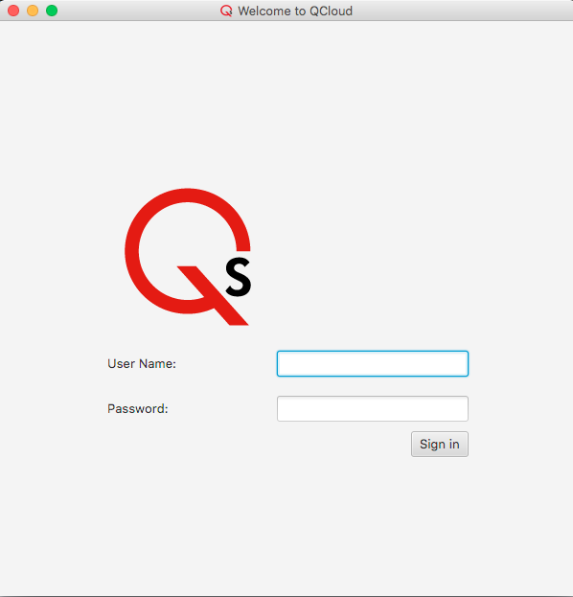

Step 6 : Enter the QCloud User Credentials and click on “Sign in”

The Oracle fusion audit expect two files to be available in the location where the QAgent is launched. And the file name should be in the name as below

-ALLUSERROLES.CSV

-ALLROLES.CSV

These files should be generated and available in the location of QAgent before launching the QAgent.

The steps to generate the files are mentioned in the Appendix -A. Once the files are ready continue to step7.

Step 7 : Click on the Run button to start the audit

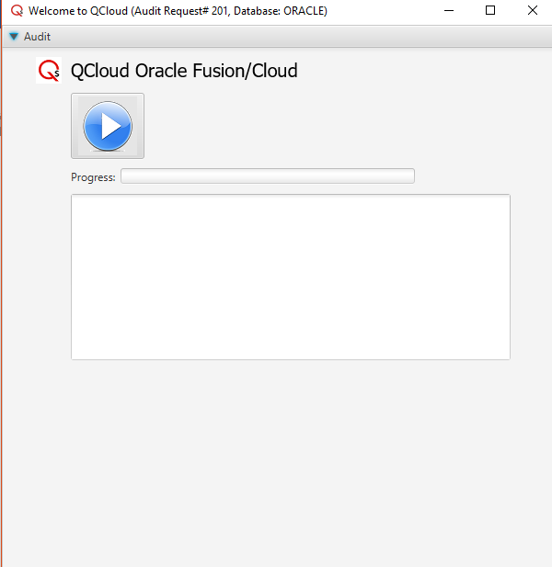

Once the upload of data is complete, the progress bar will show 100 % & an appropriate message indicating that the QSG file was uploaded into S3 will be shown.

**3. Adding remote SFTP server in OBI**

**Configuring remote SFTP server in BIP**

Step 1 : **Click on Tools -> Reports and Analytics**

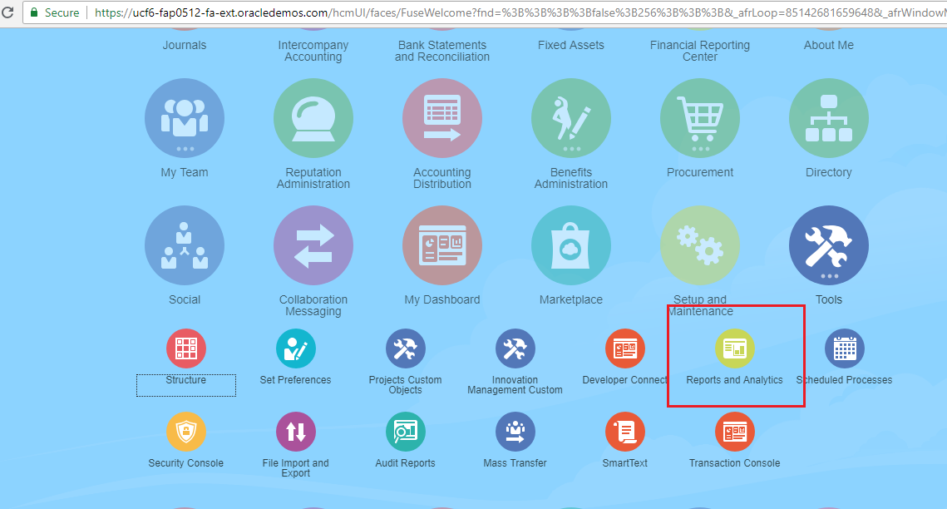

Step 2 : Click the ‘**Browse Catalog**’ icon

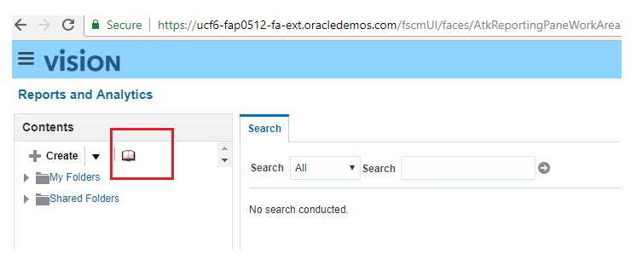

Step 3 : This will open Oracle Business Intelligence home page. In this, Go to **Administration**

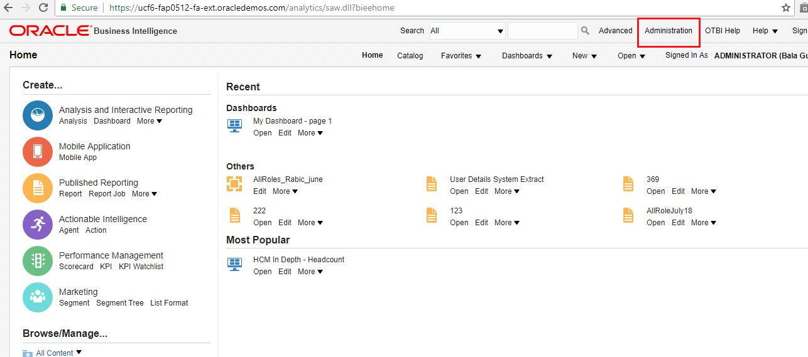

Step 4 : **BI Publisher -> Mange BI Publisher**

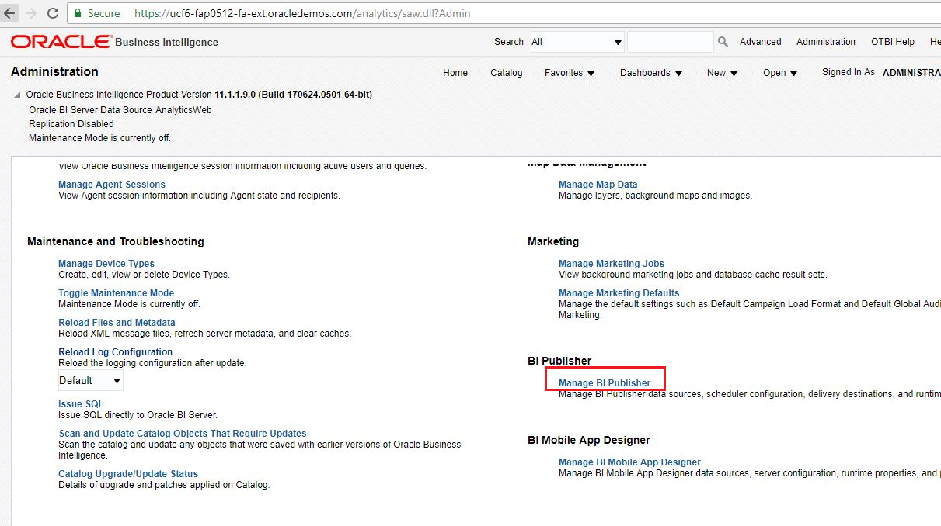

Step 5 : **Delivery -> FTP**

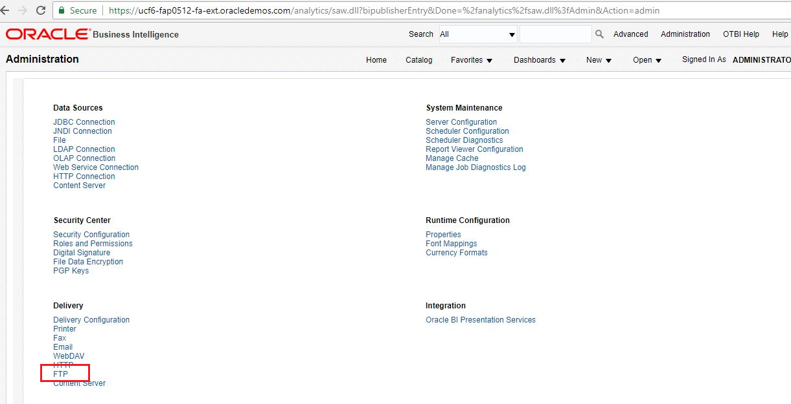

Step 6 : Add Server

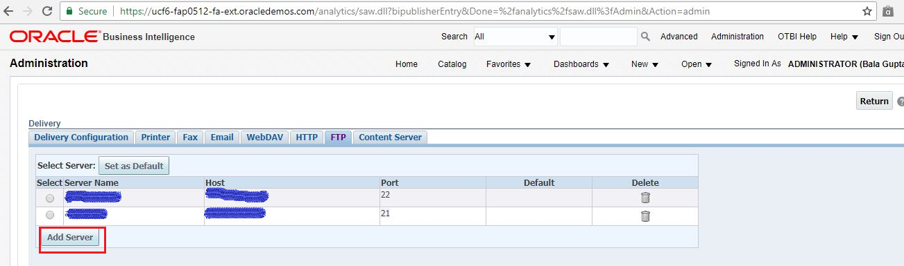

Step 7 :

Enter the details like Server Name, Host IP

Port should be always 22 and select, Use Secure FRP to **‘true’**

Enter Username and Password

Step 8 :

Once entered all the required details click **‘Test Connection’** to verify the connection to SFTP server works fine., and click ‘**Apply’** to save the changes.

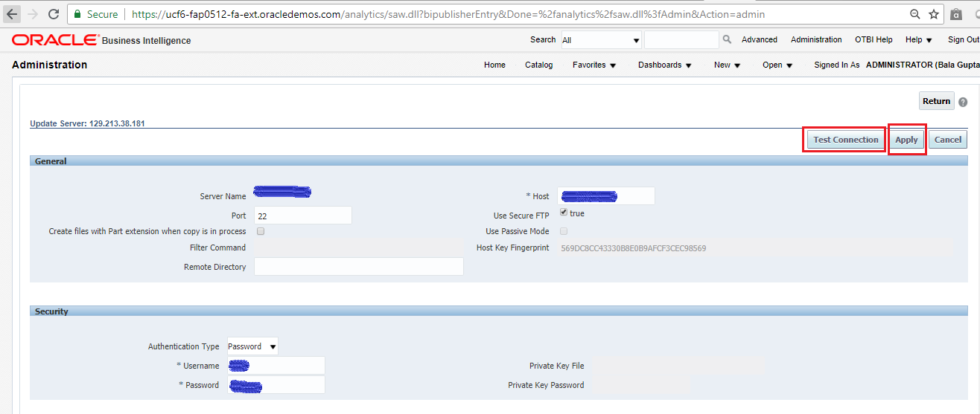

If the test connection fails and facing any difficulties setting-up the ftp server please check the oracle document in oracle support page “Fusion Applications BI Publisher : How to request an external SFTP Port in order to deliver BI Publisher reports to an external SFTP server (Doc ID 1924562.1)”

**4. Firewall access for QAgent**

QAgent would need access to the following sites for the Oracle Fusion Clould Customer Data to be processed successfully.

1. qcloud.qsoftware.com
2. qsoft.qcloud.audit-file.s3-us-east-1.amazonaws.com
3. qsoft.qcloud.audit-file.s3.amazonaws.com

**5. Generating the ALLROLES.CSV file**

The details to generate ALLROLES.CSV file required for the audit is given in the following**.**

**Using BIP by creating custom data-model and report**

Check the video ‘fusion_cloud-How to add sftp server and create report using custom datamodel’

**Query to generate ALLROLES_(APP NAME).CSV.**

Select distinct role_b.CODE ROLE_NAME,

rolevl_c.ROLE_NAME ROLE_DISPLAY_NAME,

rolevl_c.DESCRIPTION ROLE_DESCRIPTION,

app_b.App_Name APPLICATION_NAME,

CAST (NVL2(rolevl_c.ROLE_NAME, role_b.CODE || '(' || rolevl_c.ROLE_NAME || ')', role_b.CODE) AS VARCHAR2(2)) INHERITED_ROLE_HIERARCHY,

role_b.CODE INHERITED_ROLE_NAME,

rolevl_c.ROLE_NAME INHERITED_ROLE_DISPLAY_NAME,

rolevl_c.DESCRIPTION INHERITED_ROLE_DESCRIPTION,

role_b.ROLE_TYPE_CODE INHERITED_ROLE_CATEGORY,

NVL(ase_p_vl.CODE, 'NO DATA AVAILABLE') as ENTITLEMENT,

NVL(ase_p_vl.NAME, 'NO DATA AVAILABLE') as ENTITLEMENT_DISPLAY_NAME,

NVL(ase_p_vl.DESCRIPTION, 'NO DATA AVAILABLE') as ENTITLEMENT_DECSRIPTION

From fusion.ase_role_b role_b

join fusion.ase_priv_role_mbr ase_priv_role_mbr on role_b.ROLE_ID = ase_priv_role_mbr.ROLE_ID

left join fusion.ase_role_role_mbr rolembr on ase_priv_role_mbr.ROLE_ID = rolembr.CHILD_ROLE_ID

left join fusion.ase_privilege_vl ase_p_vl on ase_priv_role_mbr.PRIVILEGE_ID = ase_p_vl.PRIVILEGE_ID

left join fusion.ase_role_vl rolevl_c on (role_b.CODE = rolevl_c.CODE and rolevl_c.APP_ID = '1')

left join fusion.ase_application_b app_b on (rolevl_c.App_Id = app_b.App_Id and app_b.App_Id = '1')

where role_b.App_Id = '1'

UNION

select * from (

Select roleb_c.CODE ROLE_NAME,

rolevl_c.ROLE_NAME ROLE_DISPLAY_NAME,

rolevl_c.DESCRIPTION ROLE_DESCRIPTION,

app_b_c.App_Name APPLICATION_NAME,

Sys_Connect_By_Path( NVL2(rolevl_c.ROLE_NAME, roleb_c.CODE || '(' || rolevl_c.ROLE_NAME || ')', roleb_c.CODE), ' -> ') || ' -> '||

NVL2(rolevl_p.ROLE_NAME, roleb_p.CODE || '(' || rolevl_p.ROLE_NAME || ')', roleb_p.CODE) INHERITED_ROLE_HIERARCHY,

roleb_p.CODE INHERITED_ROLE_NAME,

rolevl_p.ROLE_NAME INHERITED_ROLE_DISPLAY_NAME,

rolevl_p.DESCRIPTION INHERITED_ROLE_DESCRIPTION,

roleb_p.ROLE_TYPE_CODE INHERITED_ROLE_CATEGORY,

NVL(ase_p_vl.CODE, 'NO DATA AVAILABLE') as ENTITLEMENT,

NVL(ase_p_vl.NAME, 'NO DATA AVAILABLE') as ENTITLEMENT_DISPLAY_NAME,

NVL(ase_p_vl.DESCRIPTION, 'NO DATA AVAILABLE') as ENTITLEMENT_DECSRIPTION

From fusion.ase_role_role_mbr mbr

join fusion.ase_role_b roleb_p on (mbr.PARENT_ROLE_ID = roleb_p.ROLE_ID and roleb_p.app_id = '1')

join fusion.ase_role_b roleb_c on (mbr.CHILD_ROLE_ID = roleb_c.ROLE_ID and roleb_c.app_id = '1')

left join fusion.ase_role_vl rolevl_c on (roleb_c.CODE = rolevl_c.CODE and rolevl_c.APP_ID = '1')

left join fusion.ase_role_vl rolevl_p on (roleb_p.CODE = rolevl_p.CODE and rolevl_p.APP_ID = '1')

left join fusion.ase_application_b app_b_c on (rolevl_c.App_Id = app_b_c.App_Id and app_b_c.App_Id = '1')

left join fusion.ase_application_b app_b_p on (rolevl_p.App_Id = app_b_p.App_Id and app_b_p.App_Id = '1')

left join fusion.ase_priv_role_mbr ase_priv_role_mbr on roleb_p.ROLE_ID = ase_priv_role_mbr.ROLE_ID

left join fusion.ase_privilege_vl ase_p_vl on ase_priv_role_mbr.PRIVILEGE_ID = ase_p_vl.PRIVILEGE_ID

Start With app_b_p.App_Id = '1'

Connect By NOCYCLE Prior mbr.PARENT_ROLE_ID = mbr.CHILD_ROLE_ID and roleb_p.app_id = '1'

Order Siblings By roleb_c.CODE, roleb_p.CODE)

Here the app_id = 1 is for the application HCM (Fusion Human Capital Management)

**For example,**

**APP NAME should be given as ALLROLES_HCM.CSV.**

**6. Generating the ALLUSERROLES.CSV file**

The details to generate ALLROLES.CSV file required for the audit is given in the following**.**

Step 1 : In the oracle fusion application home page, goto **Tools -> Reports and Analytics**



Step 2 : Click the **‘Browse Catalog**’ icon



Step 3 : Click on **New → Data Model.**

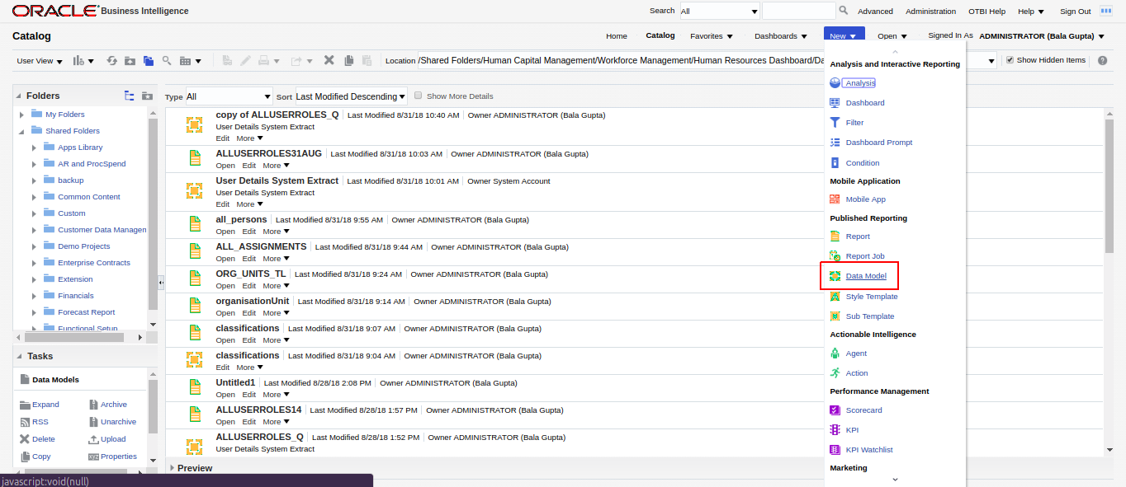

Click on New **Data set → SQL query**.

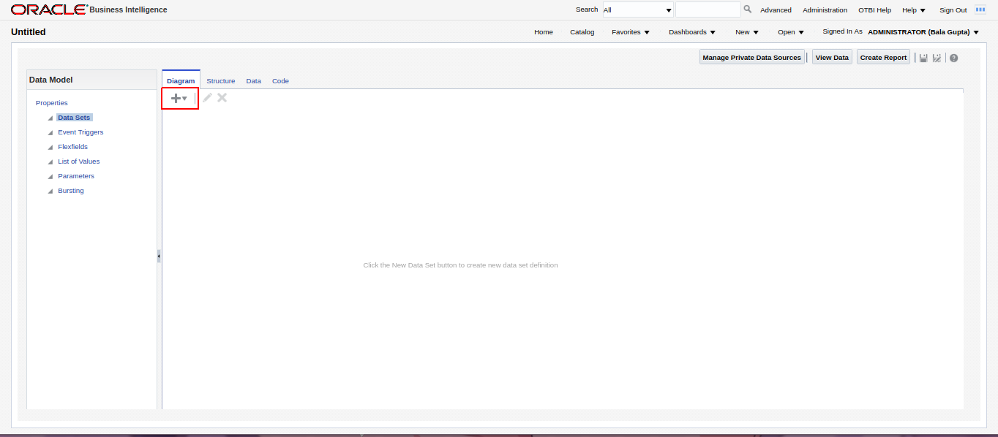

Give a name.

Select **ApplicationDB_HCM** as datasource.

Select **Standard SQL** as Type of SQL.

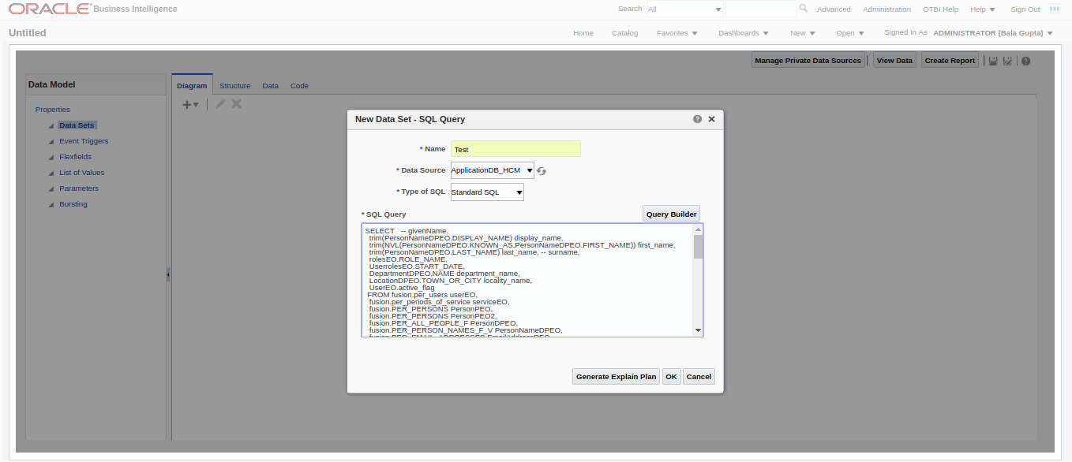

Step 4 : Now Paste the following query in SQL query section as shown in the image above.

SELECT -- givenName,

trim(PersonNameDPEO.DISPLAY_NAME) display_name,

trim(NVL(PersonNameDPEO.KNOWN_AS,PersonNameDPEO.FIRST_NAME)) first_name,

trim(PersonNameDPEO.LAST_NAME) last_name, -- surname,

rolesEO.ROLE_NAME,

UserrolesEO.START_DATE,

DepartmentDPEO.NAME department_name,

LocationDPEO.TOWN_OR_CITY locality_name,

UserEO.active_flag

FROM fusion.per_users userEO,

fusion.per_periods_of_service serviceEO,

fusion.PER_PERSONS PersonPEO,

fusion.PER_PERSONS PersonPEO2,

fusion.PER_ALL_PEOPLE_F PersonDPEO,

fusion.PER_PERSON_NAMES_F_V PersonNameDPEO,

fusion.PER_EMAIL_ADDRESSES EmailAddressPEO,

fusion.PER_DISPLAY_PHONES_V PhonePEO,

fusion.PER_DISPLAY_PHONES_V FaxPEO,

fusion.PER_ALL_ASSIGNMENTS_M AssignmentDPEO,

fusion.PER_ASSIGNMENT_SUPERVISORS_F AssignmentSupervisorDPEO,

fusion.PER_DEPARTMENTS DepartmentDPEO,

fusion.hr_all_organization_units_vl business_unit,

fusion.HR_LOCATIONS_ALL_F_VL LocationDPEO,

fusion.PER_JOBS_F_VL JobDPEO,

fusion.PER_PERSON_TYPES_VL PersonTypePEO,

fusion.PER_ADDRESSES_F AddressDPEO,

fusion.PER_user_roles userrolesEO,

fusion.PER_ROLES_DN_VL rolesEO

WHERE AssignmentDPEO.ASSIGNMENT_ID = AssignmentSupervisorDPEO.ASSIGNMENT_ID(+)

AND serviceeo.period_of_service_id = assignmentdpeo.period_of_service_id

AND AssignmentDPEO.business_unit_id = business_unit.organization_id

AND userEO.user_id = userrolesEO.user_id

AND userrolesEO.role_id = rolesEO.role_id

AND AssignmentSupervisorDPEO.MANAGER_ID = PersonPEO2.person_id(+)

AND AssignmentSupervisorDPEO.primary_flag(+) = 'Y'

AND AssignmentDPEO.primary_flag = 'Y'

AND AssignmentDPEO.ORGANIZATION_ID = DepartmentDPEO.ORGANIZATION_ID(+)

AND LocationDPEO.location_id(+) = AssignmentDPEO.location_id

AND AddressDPEO.address_id(+) = LocationDPEO.address_id

AND JobDPEO.job_id(+) = AssignmentDPEO.job_id

AND PersonTypePEO.person_type_id = AssignmentDPEO.person_type_id

AND AssignmentDPEO.effective_latest_change = 'Y'

AND PersonDPEO.PERSON_ID = PersonPEO.PERSON_ID

AND PersonPEO.PERSON_ID = PersonNameDPEO.PERSON_ID

AND PersonNameDPEO.name_type = 'GLOBAL'

AND PersonDPEO.PRIMARY_EMAIL_ID = EmailAddressPEO.email_address_id(+)

AND EmailAddressPEO.email_type(+) = 'W1'

AND PersonPEO.PERSON_ID = FaxPEO.PERSON_ID(+)

AND FaxPEO.phone_type(+) = 'WF'

AND PersonPEO.PERSON_ID = PhonePEO.PERSON_ID(+)

AND PhonePEO.phone_type(+) = 'W1'

AND (FaxPEO.Date_from =

(SELECT MAX(pff.date_from)

FROM fusion.per_phones pff

WHERE pff.phone_id = FaxPEO.Phone_Id

AND pff.date_from <= TRUNC(sysdate)

)

OR FaxPEO.Date_from IS NULL)

AND (PhonePEO.Date_from =

(SELECT MAX(pff.date_from)

FROM fusion.per_phones pff

WHERE pff.phone_id = PhonePEO.Phone_Id

AND pff.date_from <= TRUNC(sysdate)

)

OR PhonePEO.Date_from IS NULL)

AND userEO.person_id = personPEO.person_id

AND personPEO.person_id = AssignmentDPEO.person_id

AND TRUNC(sysdate) BETWEEN persondpeo.effective_start_date AND persondpeo.effective_end_date

AND TRUNC(sysdate) BETWEEN AssignmentDPEO.effective_start_date AND AssignmentDPEO.effective_end_date

AND TRUNC(sysdate) BETWEEN PersonNameDPEO.effective_start_date AND PersonNameDPEO.effective_end_date

AND TRUNC(sysdate) BETWEEN AssignmentSupervisorDPEO.effective_start_date(+) AND AssignmentSupervisorDPEO.effective_end_date(+)

AND TRUNC(sysdate) BETWEEN LocationDPEO.effective_start_date(+) AND LocationDPEO.effective_end_date(+)

AND TRUNC(sysdate) BETWEEN JobDPEO.effective_start_date(+) AND JobDPEO.effective_end_date(+)

and trunc(sysdate) between addressdpeo.effective_start_date(+) and addressdpeo.effective_end_date(+)

and assignmentdpeo.assignment_type in ('E','C','P')

and ((:From_Date is not null

and trunc(PersonPEO.start_date)>=:From_Date)

and

((:To_Date is not null

and trunc(PersonPEO.start_date)<=:To_Date)

or(:To_Date is null and trunc(PersonPEO.start_date)<=trunc(sysdate))))

and ((:User_Active_Status='Y' and UserEO.active_flag='Y')

or (:User_Active_Status='N' and UserEO.active_flag='N') or (:User_Active_Status='ALL'))

and ((:User_Population='ALL') or (:User_Population='HCM') or (:User_Population='ALL-LDAP'))

Click Ok after pasting the query.

Step 5 : Now check all 4 check boxes.

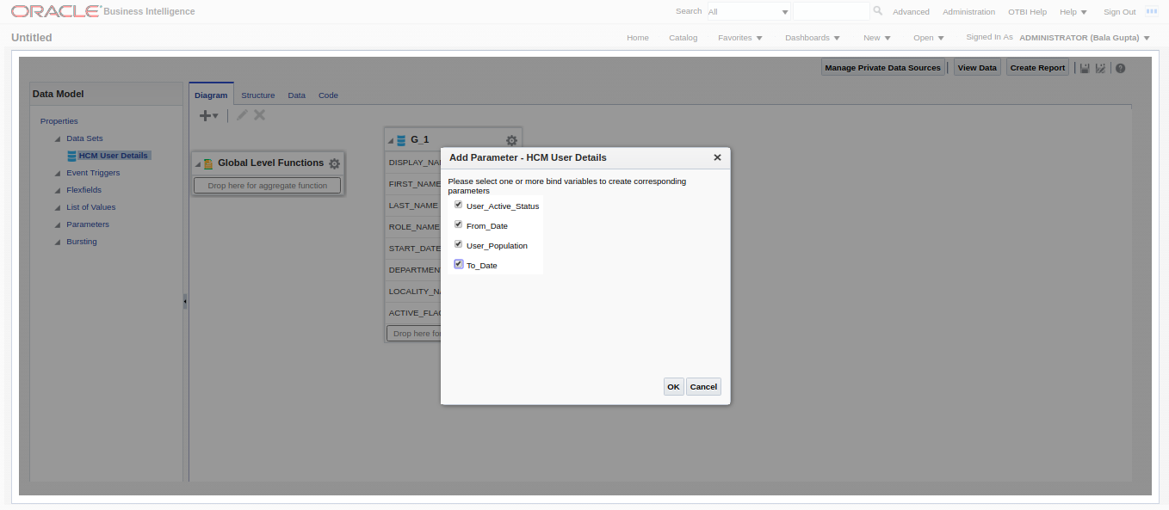

Fill the details as shown in the image below.

Order should also be same as in the image below.

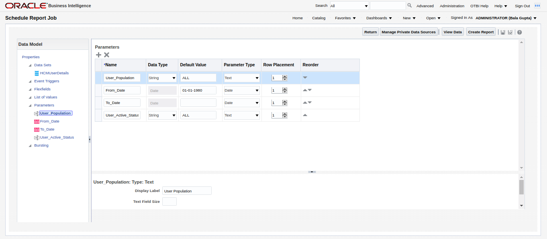

Step 6 : Click on **Properties** under Data Model.

Uncheck all 3 optionsunder **XML output options**.

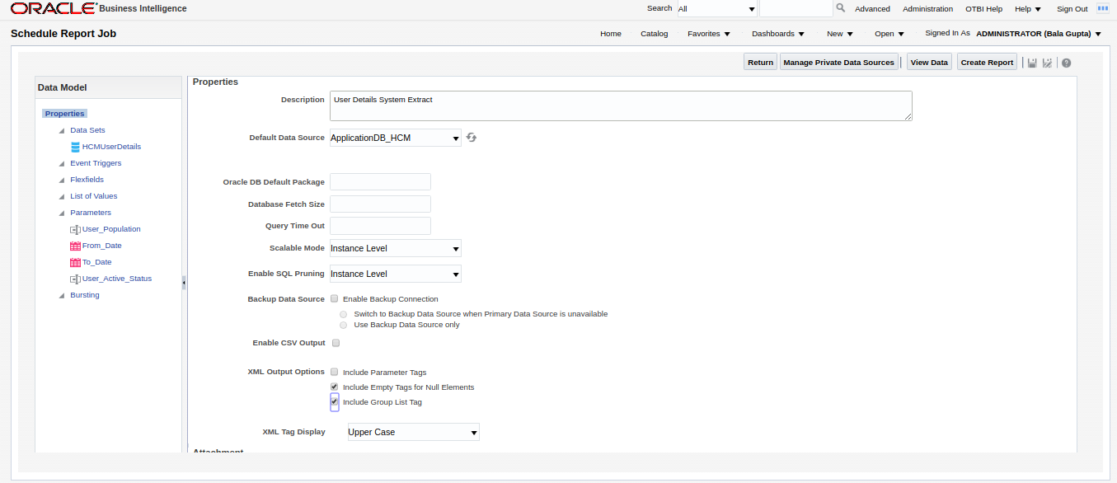

Step 7 : Click on **HCM User Details** under Data Model.

Arrange the rows in the order shown in the image below. (Drag and move the rows up and down)

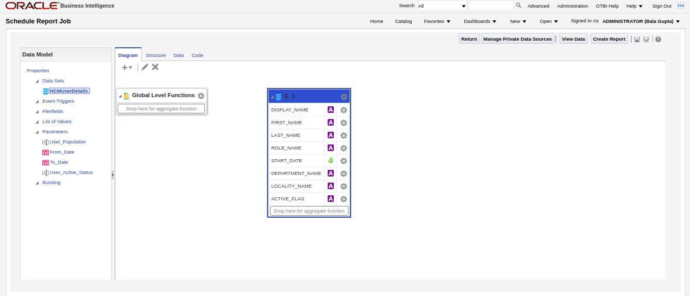

Step 9 : Click on **Data** tab.

Click on **View.**

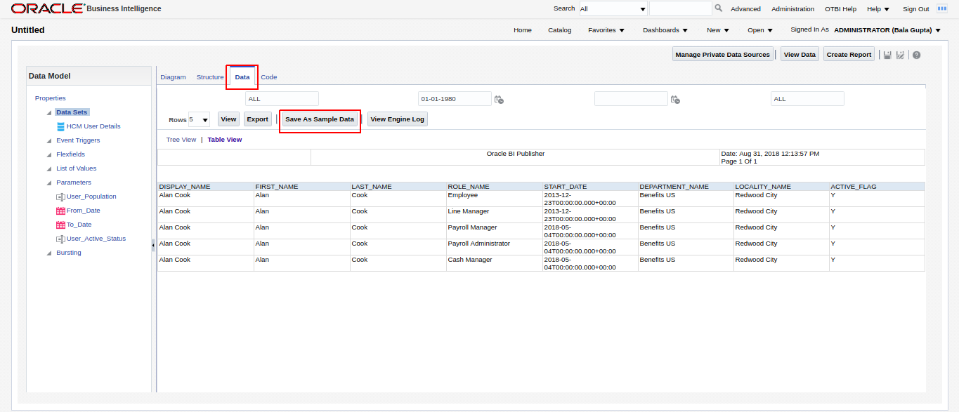

Step 10 : Click on **Save as sample Data.** Click Ok

Click **Save**.

Give a name.

Step 11 : Click **Create Report.**

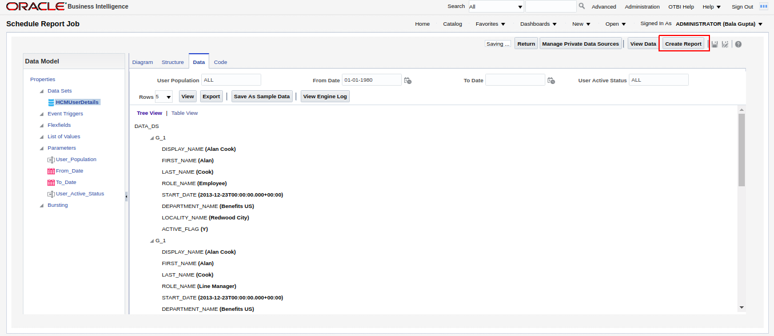

Step 12 : Click **Next.**

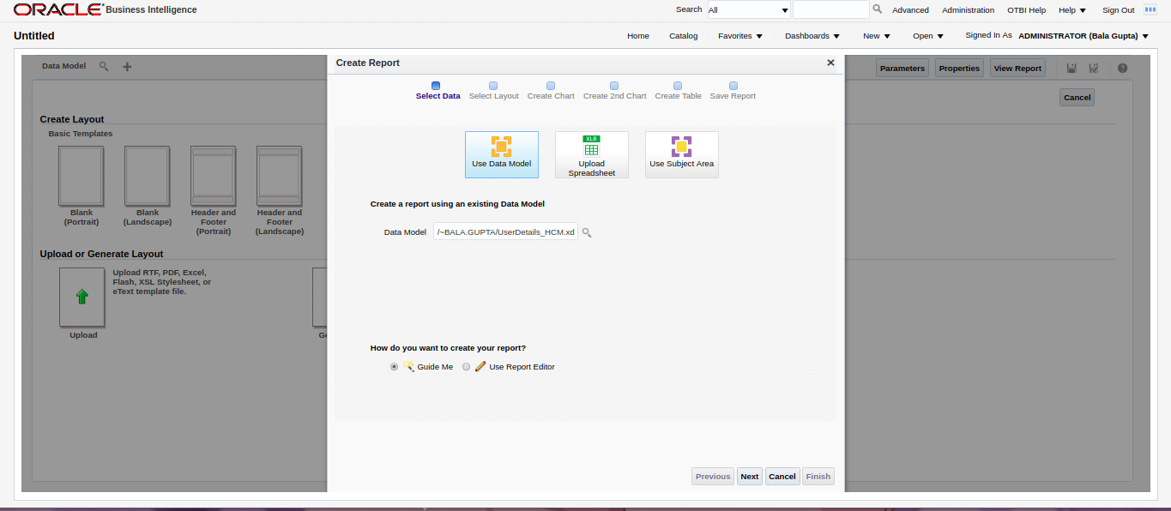

Click **Next.**

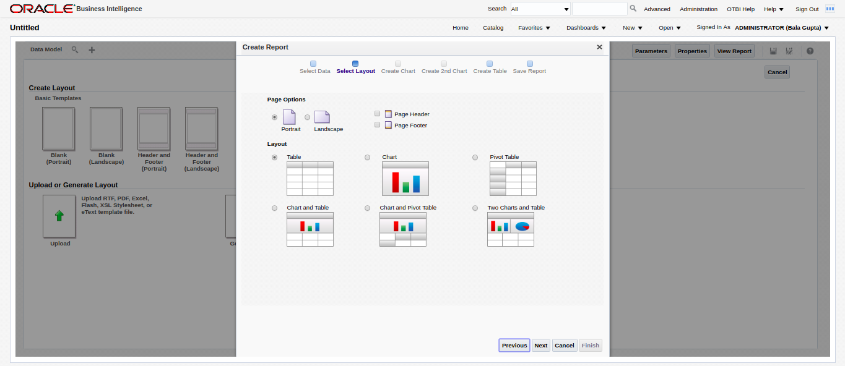

Drag and drop the items to form a table in a specific order that is shown in the image below.

DISPLAY_NAME

FIRST_NAME

LAST_NAME

ROLE_NAME

START_DATE

DEPARTMENT_NAME

LOCALITY_NAME

ACTIVE_FLAG

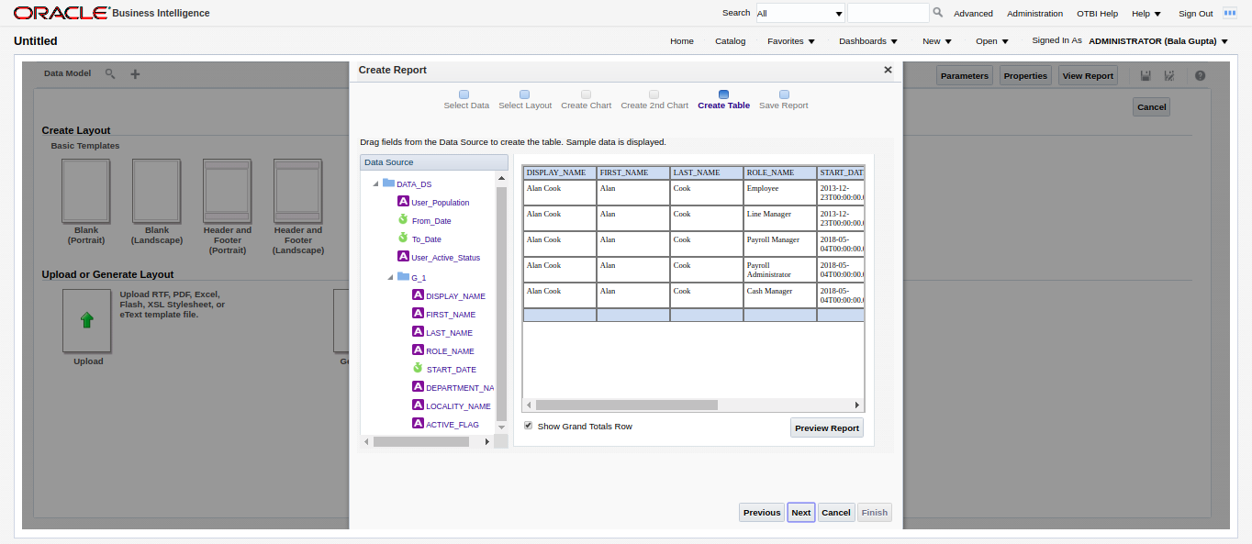

Click **Next.**

Click **Finish**. Give the name as **ALLUSERROLES**. Click **Ok**.

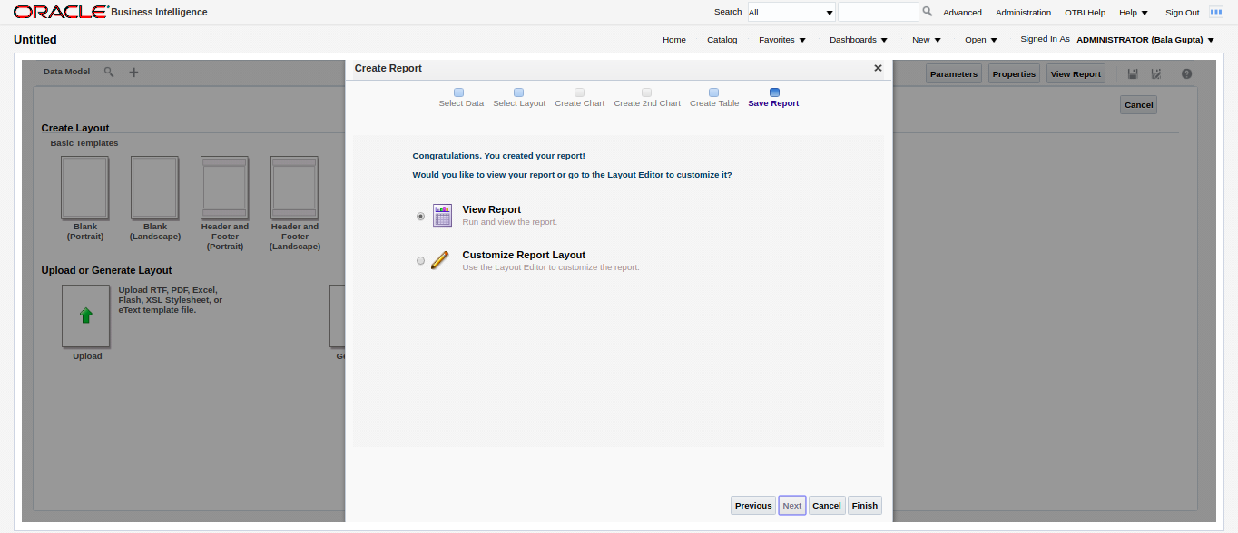

Step 13 : Click **Actions → Edit Report**.

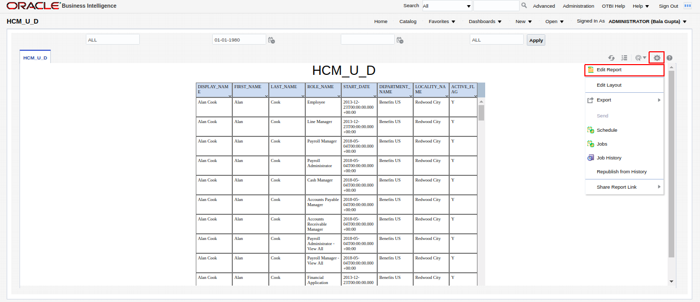

Click **View a list.**

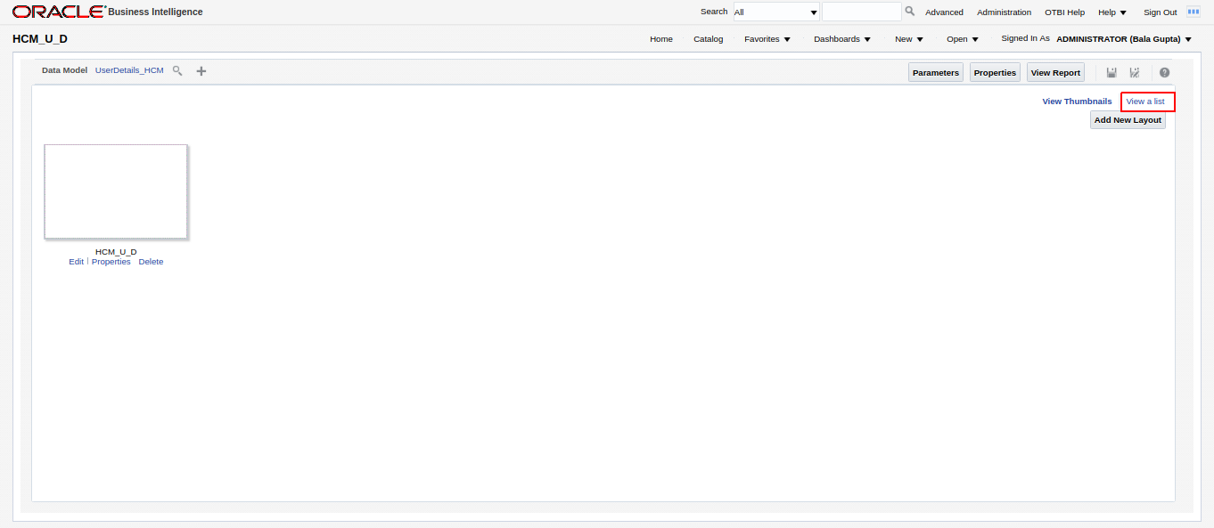

Step 14 : Select **CSV** in **Output Formats**.

Click **save.**

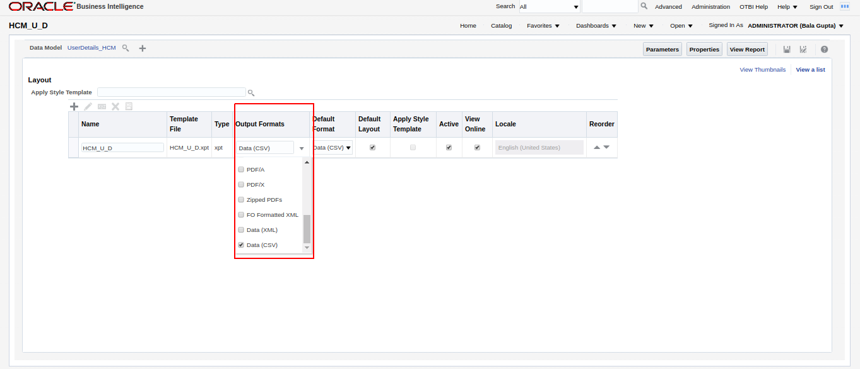

Step 15 : Click **View Report.**

Click **Actions → Export → CSV.**

The report will be downloaded.

Rename the file as **ALLUSERROLES.CSV (**if necessary**).**

**7. APPENDIX**

**Generating the ALLROLES.csv using the seeded ESS job**

Step 1 : In the oracle fusion application home page, **goto Tools -> Scheduled Processes.**

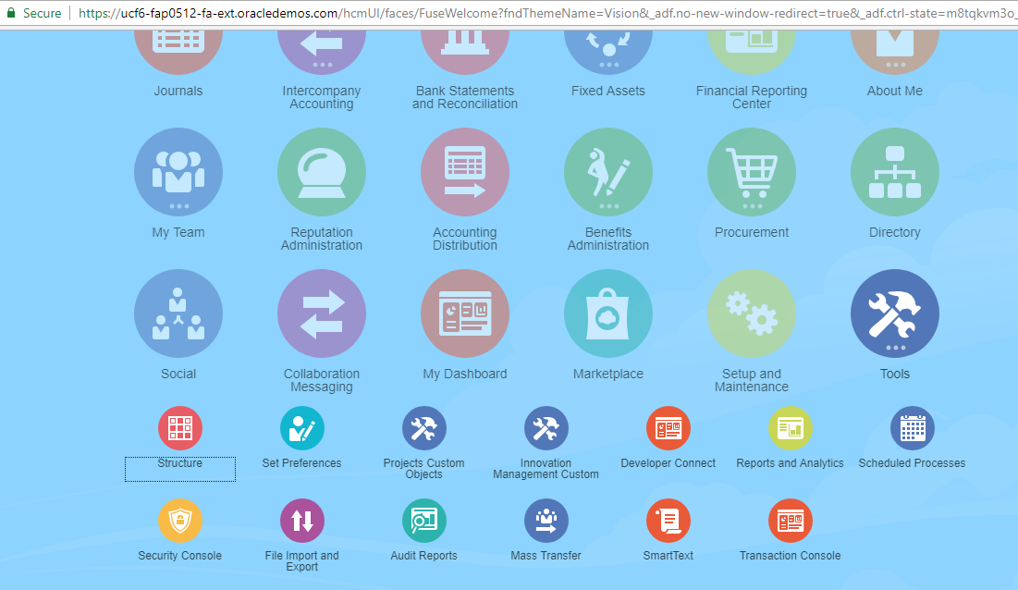

Step 2 : Click on Schedule new process. Select **‘User and Role Access Audit Report’**

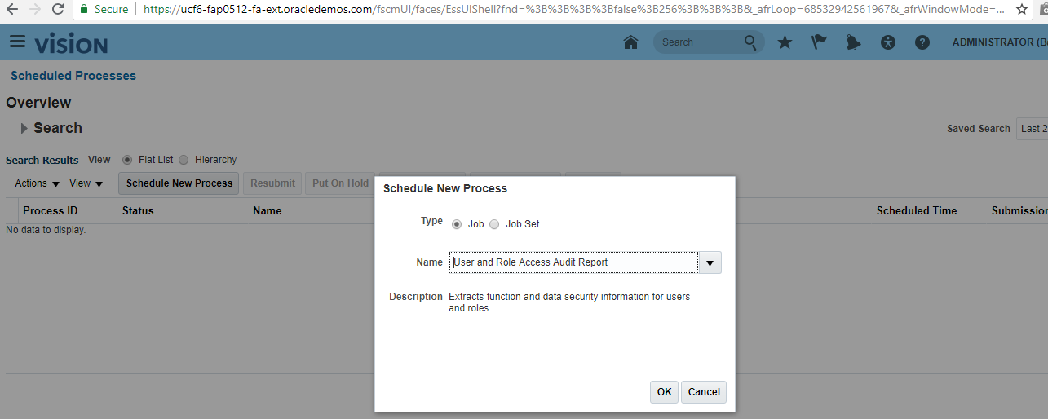

Step 3 : In the Process Details, select Report Type with value **‘All Roles’** then click Submit.

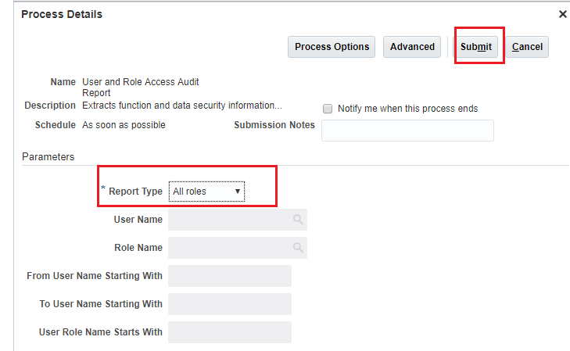

This report will take some time to complete. The report will be available in the server on successful completion.

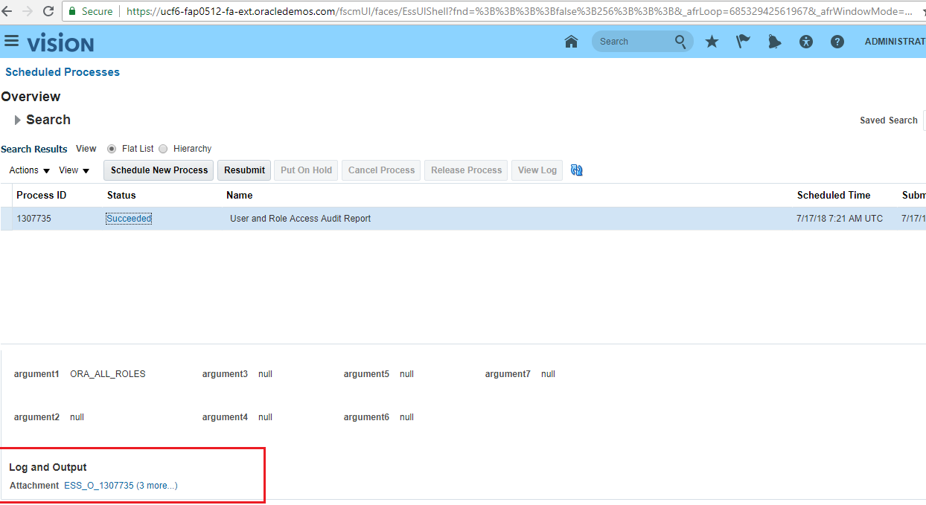

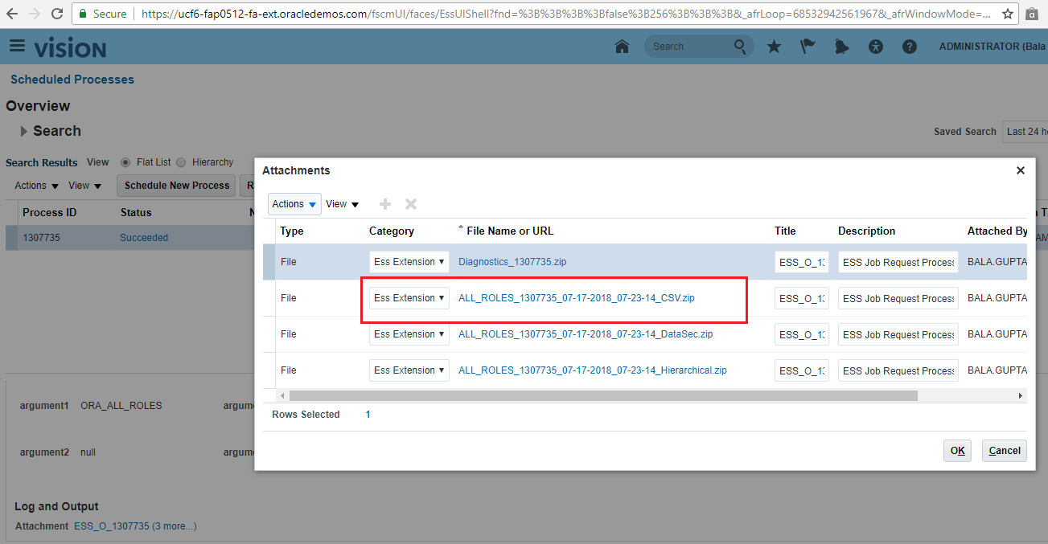

Step 4 : Download the report and extract the same. The default file name is ALL_ROLES.CSV for the Qsoft auditing please change the file name as ALLROLES.CSV and place this copy this file into the location where the QAgent is downloaded and extracted.